Inhertitance

Question 3

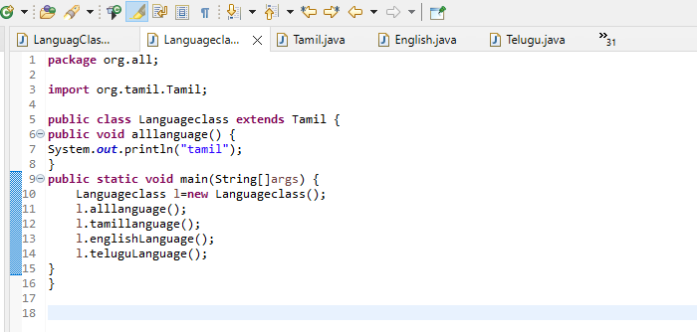

Task2

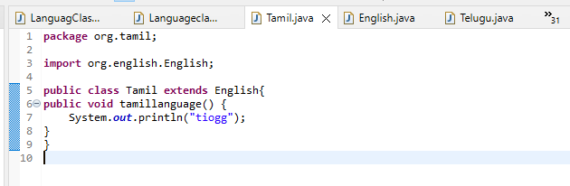

Task3

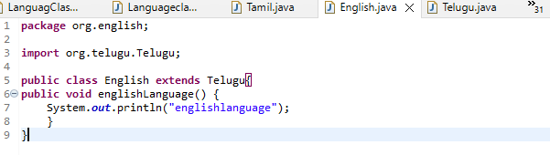

Task4

